About the filmmakers

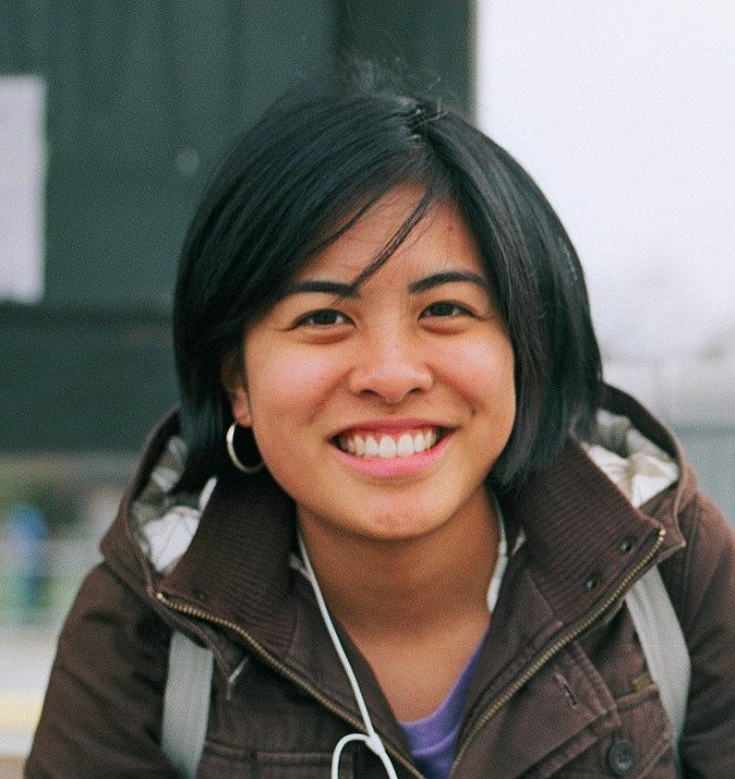

Kat Jayme- Director, Writer & Executive Producer

Kathleen Jayme is an award winning Canadian filmmaker based in Vancouver, BC, who is passionate about telling meaningful and personal stories. In 2011, she graduated from the University of British Columbia’s Film Production Program, where she wrote and directed two award winning short fiction films that screened at festivals internationally. From 2012-2016, Kathleen worked at the National Film Board of Canada where she coordinated and oversaw over thirty documentaries, animations, and digital projects through all stages of production. While working at the NFB Kathleen completed, "Paradise Island," which was nominated for two Leos: Best Documentary screenplay and Best Short Documentary and screened at the 2015 Cannes Short Film Corner.

Kathleen is a fellow of the 2016 Inspirit Foundation’s Story Money Impact program, the 2017 Hot Docs Documentary Channel Doc Accelerator program, and the 2017 Telus Storyhive Banff World Media Festival program. She has just completed her dream project Finding Big Country, which was one of 25 projects to be awarded the Telus Storyhive 100K grant.

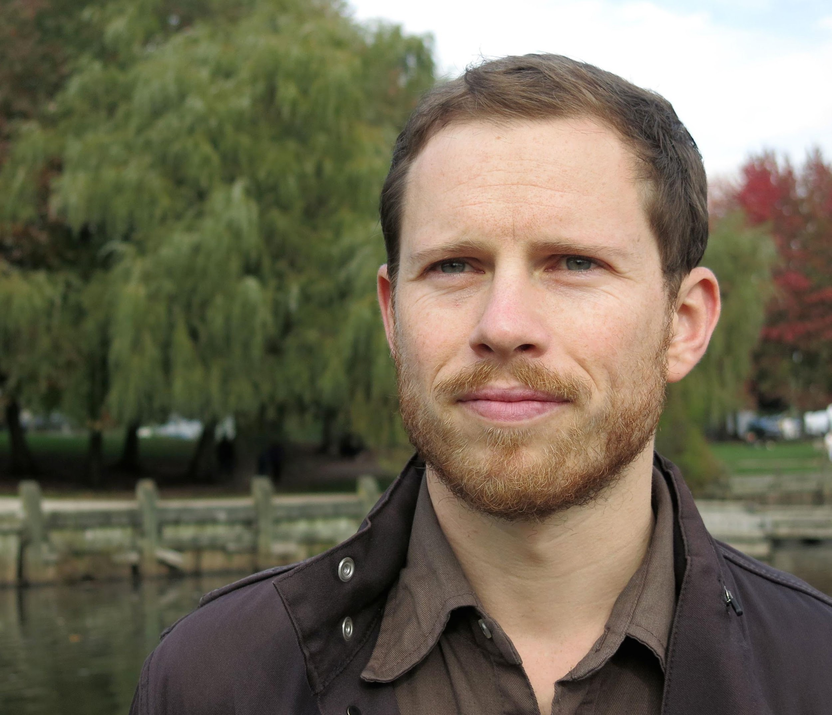

Michael Tanko Grand- Producer

While producing Finding Big Country is obviously the most important thing to know about Michael Tanko Grand, there is more to his story. Michael was the Writer and Story Producer on the 10 part documentary series Abandoned for VICELAND, and the Writer of CBC's documentary Unbroken: The Snowboard Life of Mark McMorris. Most recently Michael has been producing comedy content for Kelly&Kelly who produce CBC's This Is That among other hilarious videos and podcasts.

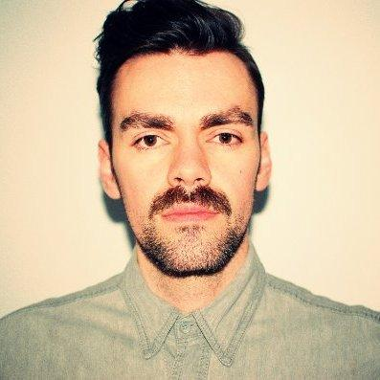

James Brown – Executive Producer

James Brown is a Canadian Screen Award nominated film and television Producer based in Vancouver. Previous works include the feature films Never Steady, Never Still (2017) which premiered at TIFF 2017 and went on to screen at over 30 international film festivals including Busan, Chicago, Valladolid, Palm Springs, Dublin and Beijing. The film was nominated for 8 Canadian Screen Awards including Best Picture. Other credits include the feature, Down River (2013) starring Helen Shaver, and short film The Future Perfect (2015) starring Zachary Quinto and Robert Baker. For television, he has produced the 1st season of the animated series Chuck’s Choice for DHX Media and Corus Entertainment, and the 2nd season of Cloudy with a Chance of Meatballs for DHX Media, Sony Pictures Animation and Corus. Along with the talented team working on Finding Big Country, he’s working on another documentary about hockey in North Korea, having been given extremely rare access to shoot with their National Hockey team.

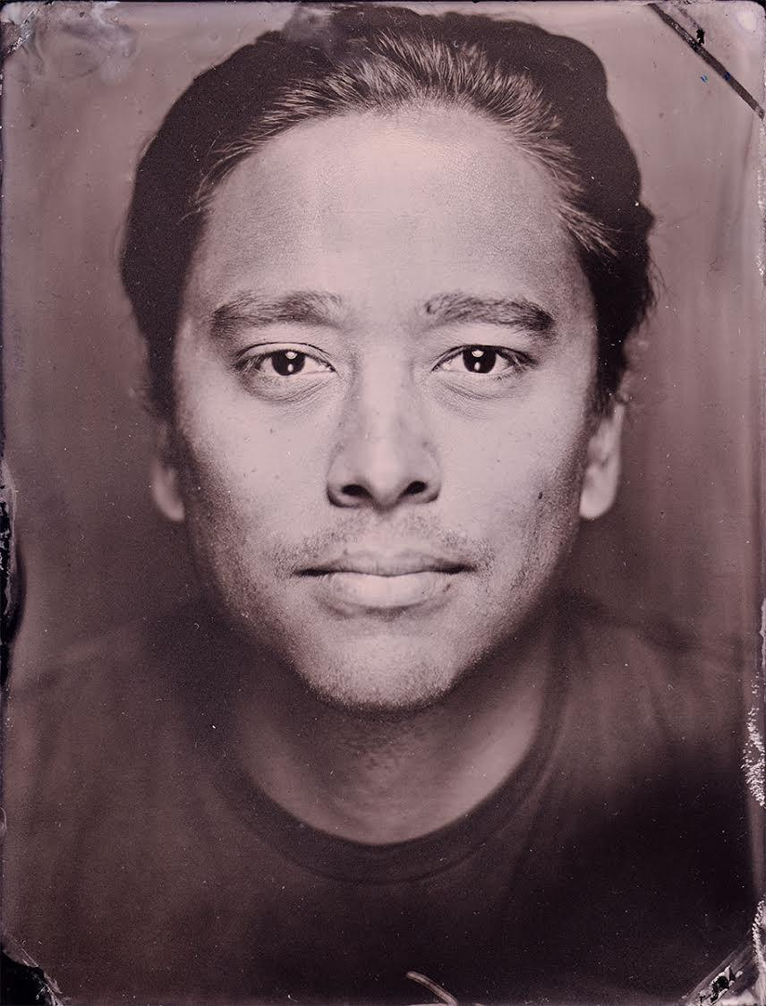

Greg Ng- Editor
Greg Ng is an award winning film editor from Vancouver, B.C. He is an alumnus of the UBC Film Program and the Canadian Film Centre. Most recently, Greg finished working on the Vice documentary series The Wrestlers, which explores the fascinating characters in independent wrestling around the world. In his spare time, he is an amateur Vanagon mechanic.

Michael Dinsmore- Cinematographer
Mike Dinsmore is a Vancouver based director and DP, who has spent the last 10 years shooting and directing documentary series and films, short dramas and commercial spots.
Known for his work on observational docs like CBC’s This is High School and Keeping Canada Alive and Smithsonian’s Polar Bear Alley, to being embedded on fast-paced, high pressure series like History Channel’s Ice Pilots and Yukon Gold and Discovery Channel’s Highway Thru Hell, Mike has honed an ability to shoot in any style, in any environment, from solo missions in the frigid reaches of Iceland, to overseeing 50 remote cameras in a suburban high school. His preference is for strongly composed and beautifully lit images that tell a raw, unyielding story.

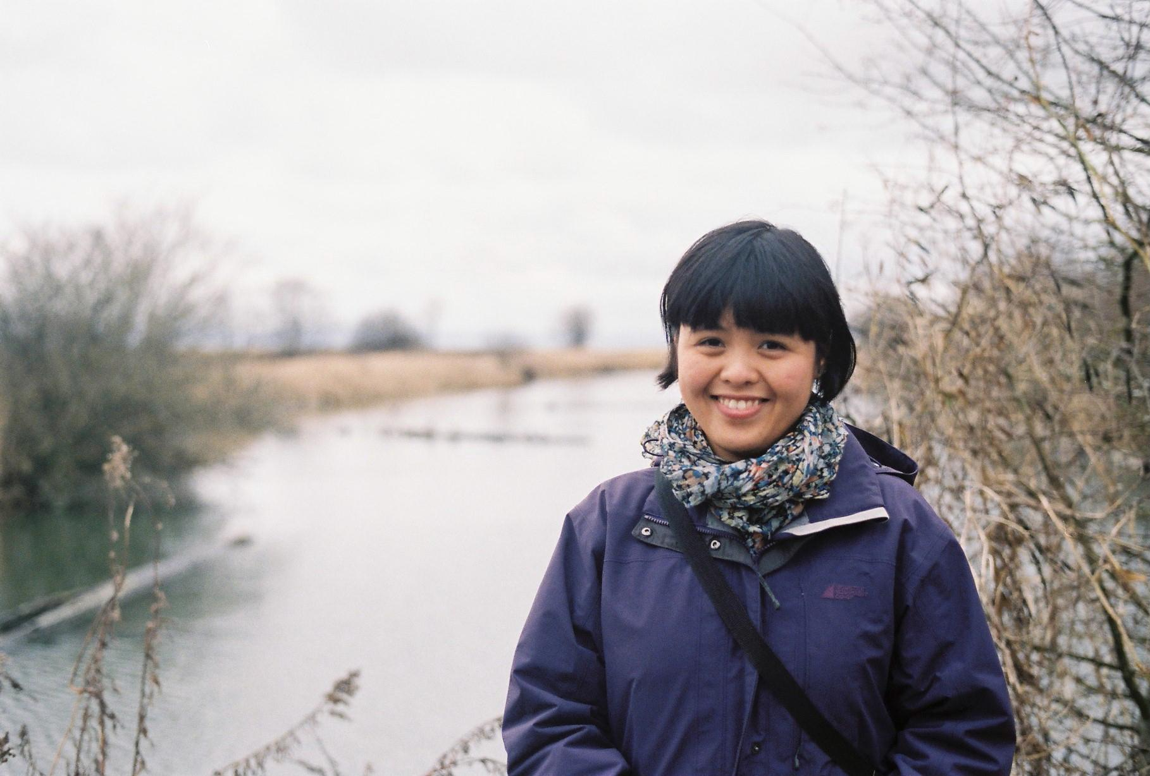

Lisa Pham Flowers – Assembly Editor

Lisa Pham Flowers is a Vietnamese-Canadian filmmaker from Vancouver BC with a unique talent for finding heart, motion, and creating story. Lisa has over a decade of experience mentoring and teaching filmmaking to youth, and is currently working as an editor in Vancouver. Her editing work comprises a wide-range of narrative short films, music videos, commercial projects, and documentaries. She is currently in post-production on a collaborative first feature titled 'JIMBO: True Delusions'

